

Otto Optics Full Stack Odyssey!

**Sunil** **Ghate**

# Otto Landing Page

Retrieve all the records based on request param.

* Search Option: Search with keyword for e.g. “Mayra”
* Filter Option: Filter the listing with Director Occupation list
* Sort Option: Sort the list with options available.

Link: <http://localhost:8080/Otto/public/index.php?fetch=records>

Screenshot:

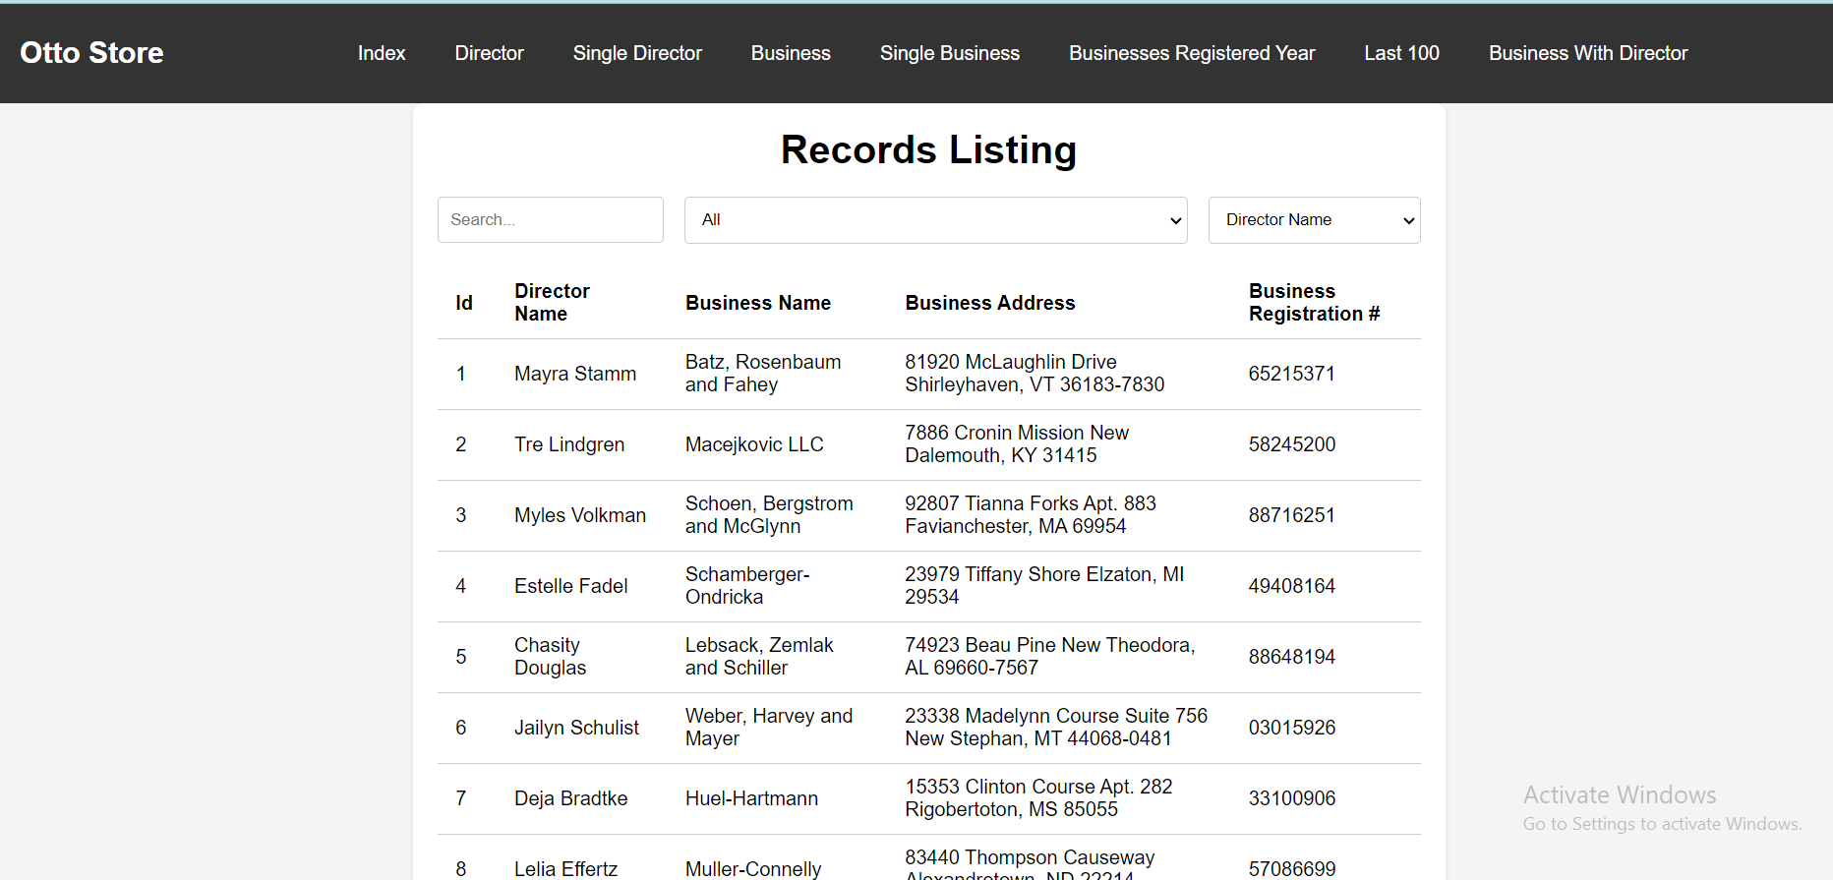

# Otto Director Page

Retrieve all the director records.

* Search Option: Search with keyword for e.g. “Mayra”
* Filter Option: Filter the listing with Director Occupation list
* Sort Option: Sort the list with options available.

Link: <http://localhost:8080/Otto/public/index.php?fetch=director>

Screenshot:

## 

# Otto Single Director Page

Retrieve a single director record with a given id.

Link: <http://localhost:8080/Otto/public/index.php?fetch=single-director&id=1>

Screenshot:

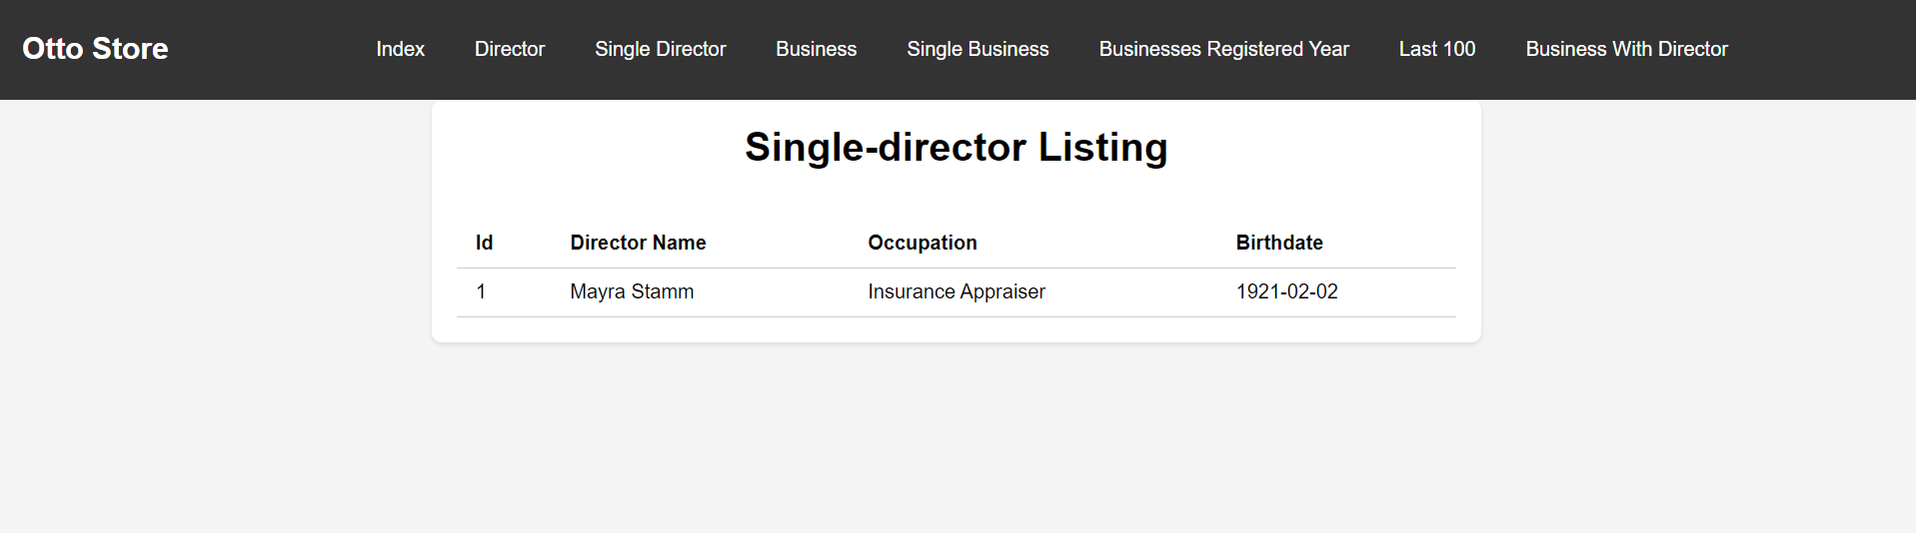

# Otto Business Page

Retrieve all the business records.

* Search Option: Search with keyword for e.g. “Mayra”
* Sort Option: Sort the list with options available.

Link: <http://localhost:8080/Otto/public/index.php?fetch=business>

Screenshot:

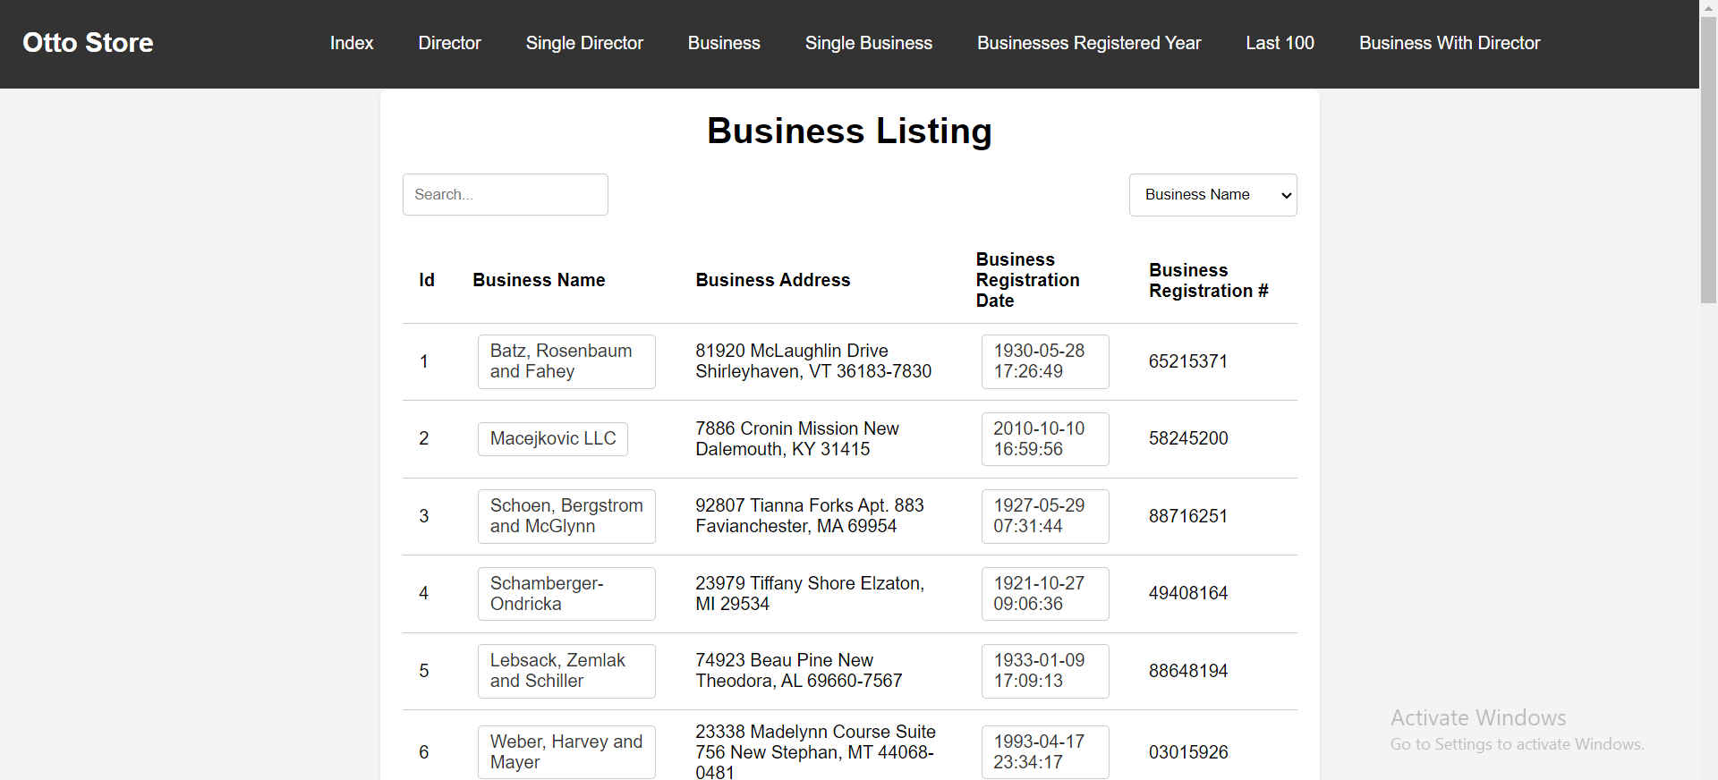

# Otto Single Business Page

Retrieve a single business record with a given id.

Link: <http://localhost:8080/Otto/public/index.php?fetch=single-business&id=1>

Screenshot:

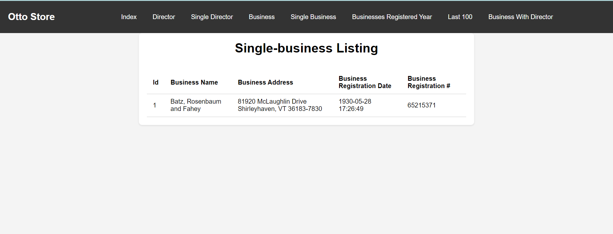

# Otto Business Registered Year Page

Retrieve a list of all businesses registered on a particular year.

Link: <http://localhost:8080/Otto/public/index.php?fetch=businesses-registered-in-year&id=1989>

Screenshot:

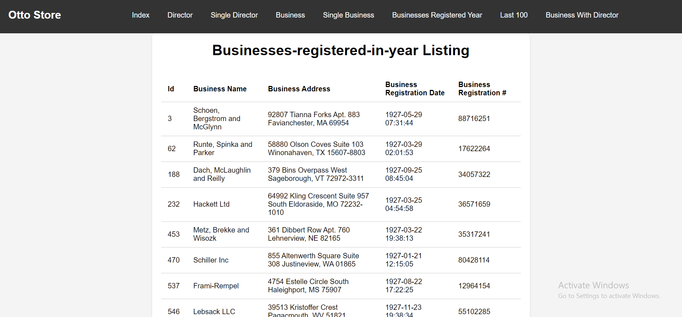

# Otto Last 100

Retrieve the last 100 records in the directors table.

* Search Option: Search with keyword for e.g. “Mayra”
* Filter Option: Filter the listing with Director Occupation list
* Sort Option: Sort the list with options available.

Link: <http://localhost:8080/Otto/public/index.php?fetch=last-100>

Screenshot:

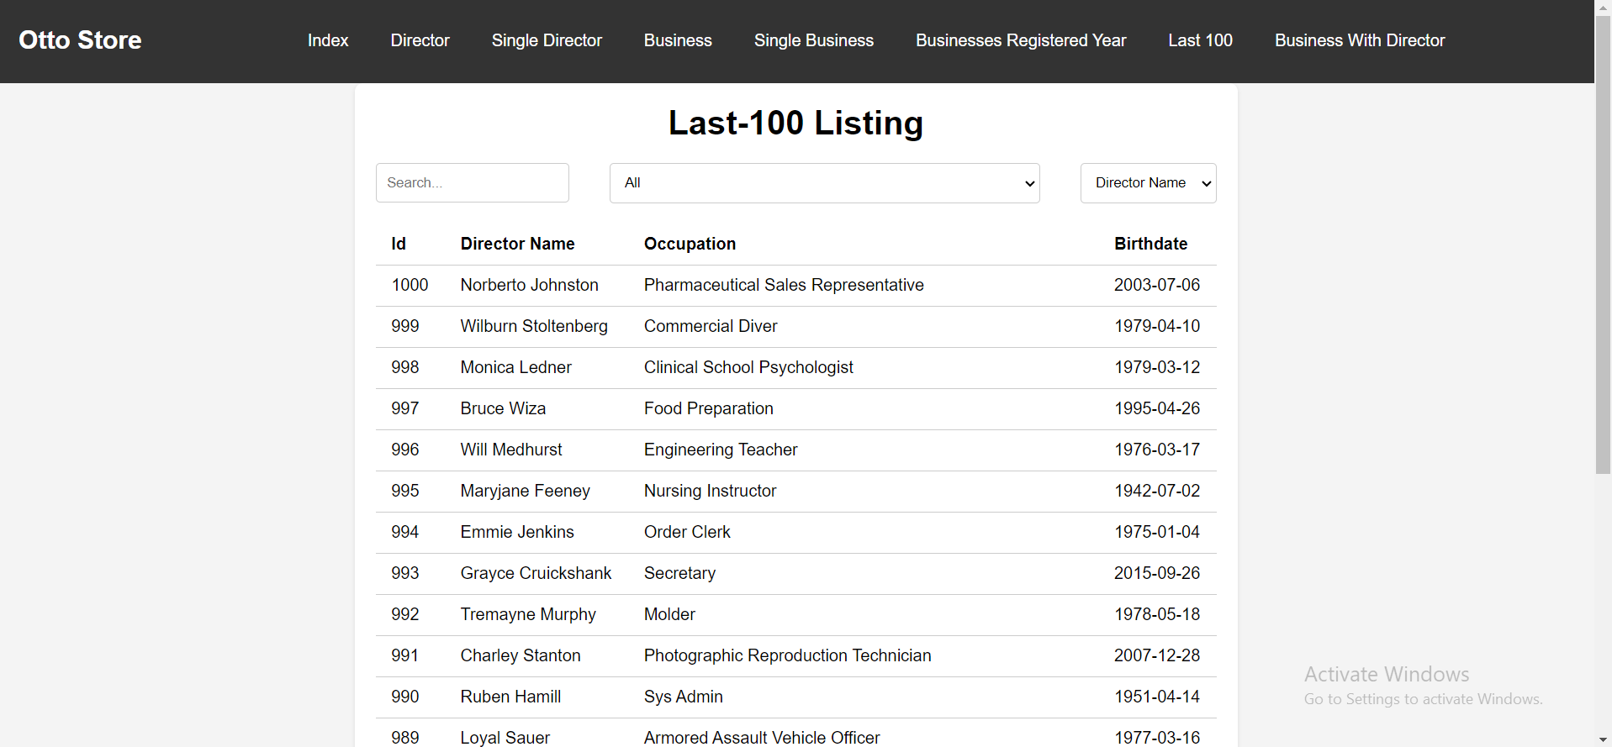

# Otto Business and Director Page

Retrieve a list of all business names with the director's name in a separate column. The links between directors and businesses are located inside the director_businesses table.

* Search Option: Search with keyword for e.g. “Mayra”
* Sort Option: Sort the list with options available.

Link: <http://localhost:8080/Otto/public/index.php?fetch=business-name-with-director-fullname>

Screenshot:

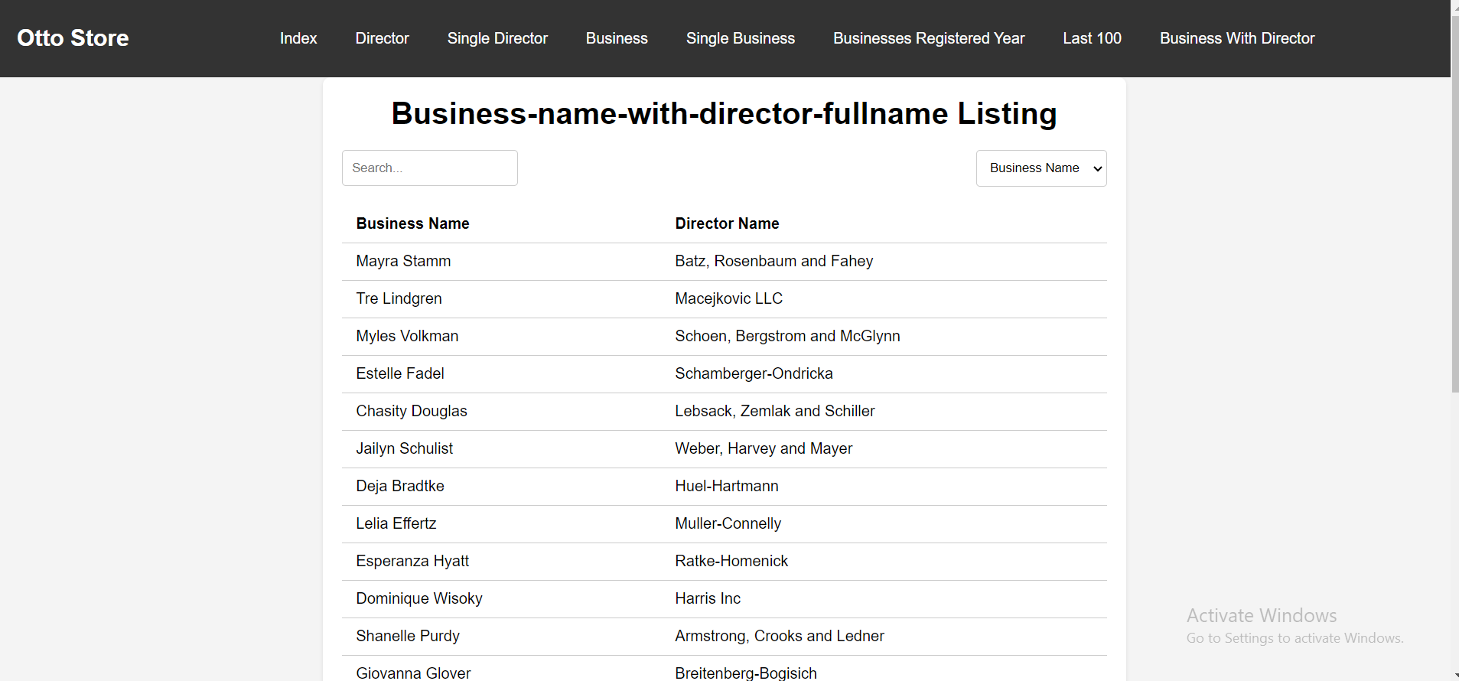

Pagination Implementation

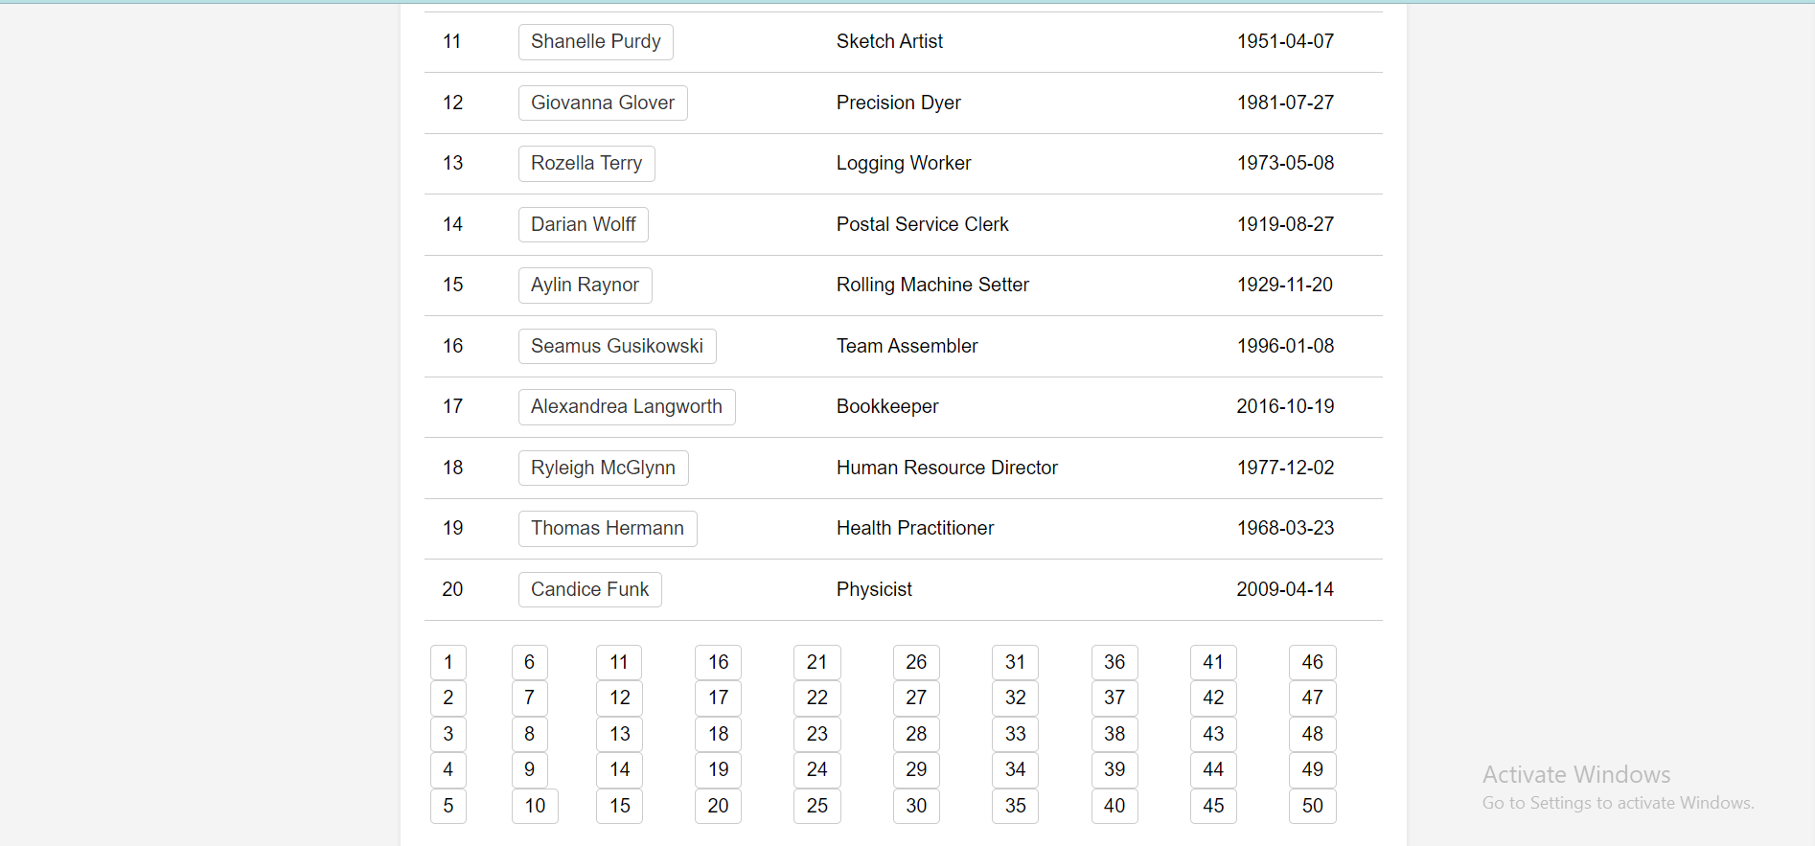

Search, Filter and Sort Implementation

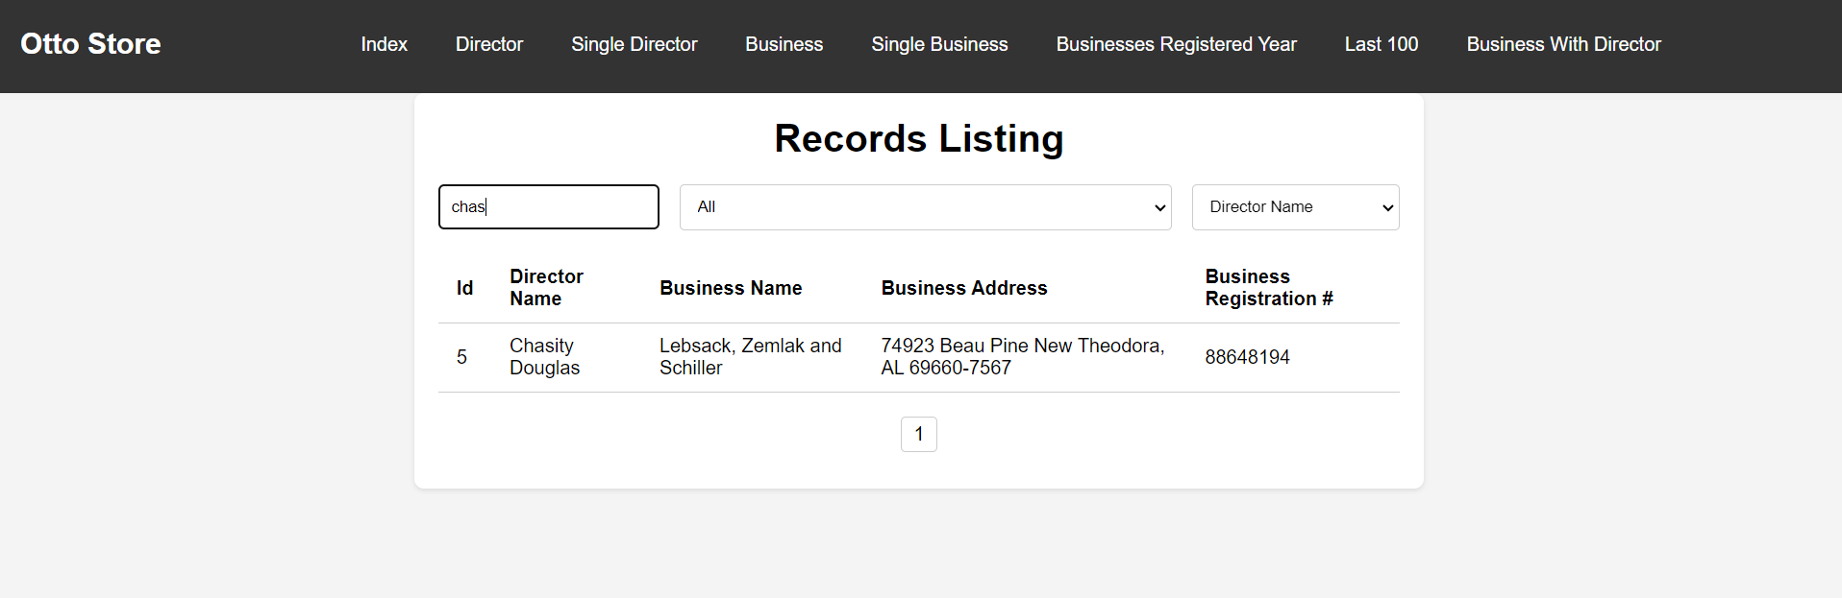

Thank You